Dear Parents/Carers,
Year 6 have been really engrossed in their topic, War Horse, this half term. As we move towards the end of this topic, we have a number of exciting opportunities available to our children.
Year 6 Evacuee Day
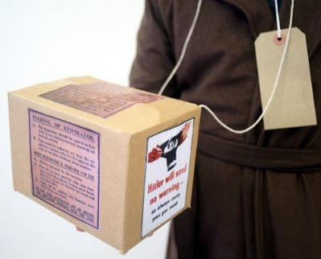
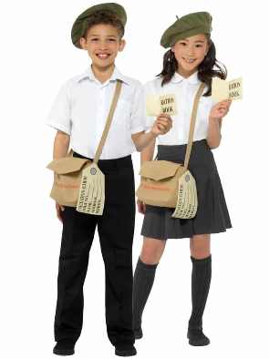
On Wednesday 19th October 2022, we would like to hold a WWII themed evacuee day. This will involve your child coming into school dressed as an evacuee from this period in time (see photo). As part of their Home Learning task this week, we would also like your child to make and bring in their very own gas mask box (see photo-we will provide the labels if needed).
War Horse Movie
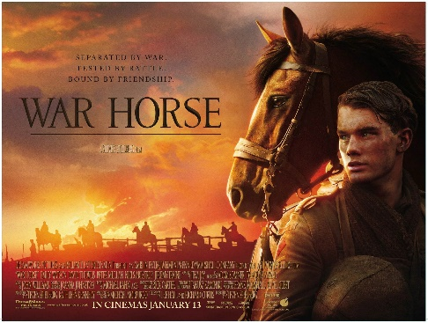
On our final day we would like to show the children a clip from the War Horse movie. This will enable our children to witness what happens in the closing stages of the book when Joey is reunited with his owner, Albert. We are aware that this movie has an age rating of 12A but have watched this part of the film to ensure it is suitable for our children. Please use the following link to watch this for yourselves: https://vimeo.com/454673816. To confirm that you are happy for us to show this to your child please complete the reply slip below.
Science- Drugs and Alcohol
In the last of our Science lessons on ‘Animals, including humans’, we will be studying the effects of drugs (smoking) and alcohol on the human body. More specifically, we will be looking at how smoking and drinking alcohol was commonplace amongst soldiers during the war and the health repercussions of these habits on the human body.
Best wishes,
The Year 6 Teaching Team.
___________________________________________________________________
Name:

I give permission for my child to watch the above video clip from War Horse (12A).

I do not give permission for my child to watch the above video clip from War Horse (12A).
Date: Signed:

